Lubensky Lab Vertex Model Tutorial 1
Last Updated By: Avik Mondal
03-01-2020

This tutorial is meant to help new members of the Lubensky lab get acquainted with our Vertex model software. Before you start the tutorial you should have at least a basic understanding of what a vertex model is. The best way to do this is by talking to Dr. Lubensky and the other group members. If you want to go through the math step-by-step read section 2 of our paper https://arxiv.org/pdf/1609.08696.pdf. Once you feel comfortable with the mathematics of the model please read the chapter on implementing the vertex model in Meryl Spencer’s thesis (in this folder). This will give you a good overview of the components of the code and how they fit together.

Everything you need for the rest of this tutorial can be found in the folder vertex model tutorial on the group server (if you don’t know where this is ask). For the rest of the tutorial we will assume that you understand the basics of how to code in C++. If you are new to programming we recommend spending a week or two getting comfortable with the following topics:
- loops and if statements
- C++ vectors
- pointers
- objects and object-oriented programming
You don’t need to understand everything in excruciating detail. You will pick up what you need to know as you start working with the code. Stack exchange is a great website for finding answers to almost all programming questions.

For a nice, unified source on C++, the office usually has a copy of “C++: How to Program” by Deitel floating around.

Tutorial 1: Setting up a working version of the code
The biggest hurdle to using the code is getting it set up and running for the first time. If Hayden or Avik is around ask for their help, otherwise follow these instructions.

If you’ve programmed in C++ before feel free to use whatever IDE you are most comfortable with. The base code is known to compile without error in Visual Studio express 2013, and in the Linux environment on FLUX. If you’re new to C++ we strongly recommend using Visual Studio to compile and run your code.

If you are using visual studio we have set up a project with all of the .h and .cpp files already included. Copy the tutorial folder to your machine and double click on CPP Code\VertexModelBase\ VertexModelBase.sln. If you downloaded visual studio correctly you should get a screen that looks like this: 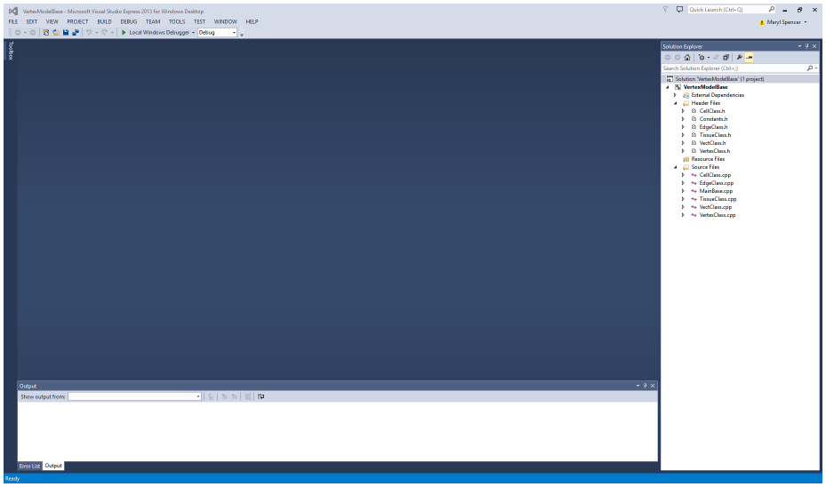
On the side you should have a soultion explorer tab. When you click on the file names they will open in the rest of the window. Try opening the MainBase.cpp file. You should see something that looks like this: 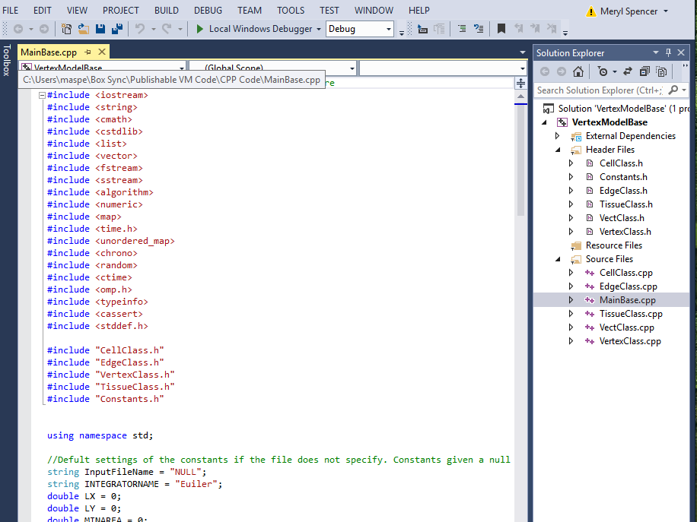
You can look through all the files and edit them this way. If you want to know what functions are available look in the header files.

Quest 1: Find the int GetEdgeNumber(); function in the VertexClass.h file. Right click on it and select ‘go to definition’ as shown below
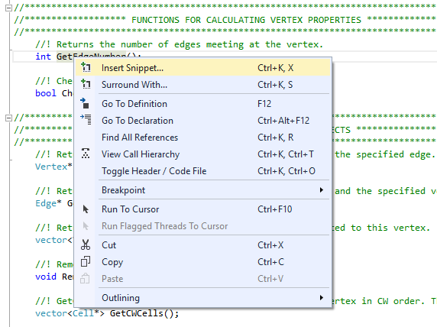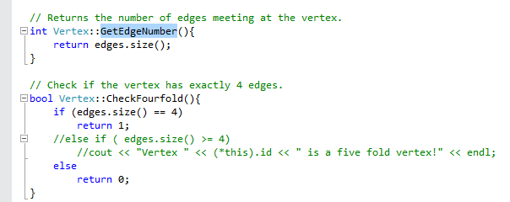
Clicking the “go to definition” button will open the VertexClass.cpp file and take you to the definition of the function. In this case we just return the size of the vector holding the pointers to the edges.

Quest 2: Make a simulation!

part a) Open InitialConditions_Voronoi.m and run it. The following figure will pop up
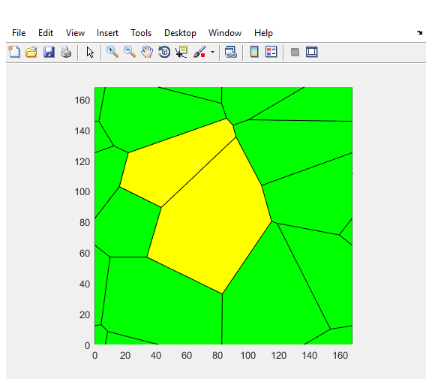
This is what our starting point looks like. You can close this window. You will also see that a new .txt file has been created called mytissue.txt. Copy the full path name of this file for example mine is “C:\Users\maspe\Box Sync\Publishable VM Code\mytissue.txt”. Now go back to visual studio and open the MainBase.cpp file. Edit the first line of the main file to the path name that contains your file. Note that you will need to put two \ everywhere you would normally put one. For those new to programming, note that “\” is an escape character. Because when programming, many of the symbols mean something specific to the coding language, there needs to be a way of entering these symbols as regular text. Thus, enter the escape character, which in most languages is “\” or “\” accompanied by some other characters (this is a good thing to look up if you’re curious).
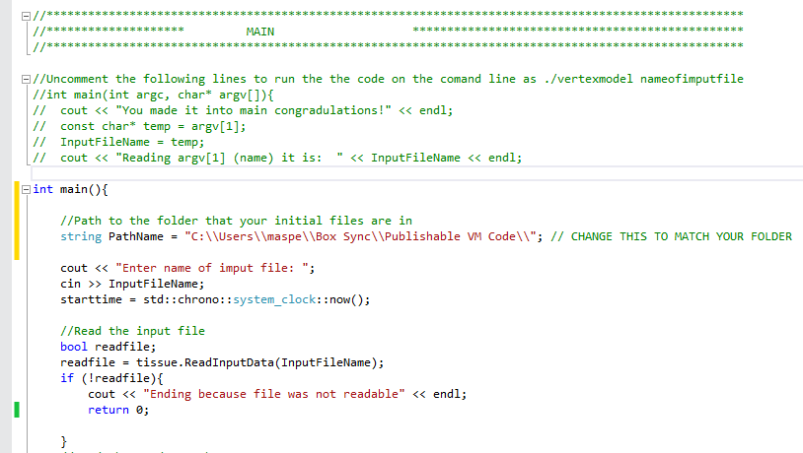
run the program by typing Ctrl+F5. Alternatively, you can use the Window options to do this. If you look up to the top menu bar, you should see the “Build” option. Hover for the drop down menu and hit “Build Solution.” This effectively compiles your code. At this point, you should not have changed anything too crazy, so there should not be any compiler errors to worry about.

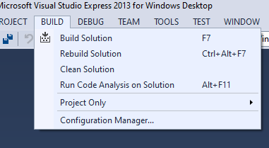

Next, to actually run the code, hover over the “Debug” button and select “Start Without Debugging” (you’ll note that this is the option to which Ctrl+F5 refers).

The following window will pop up
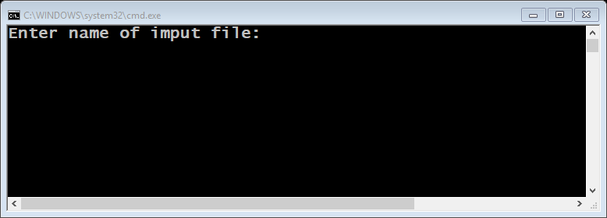
enter mytissue.txt. You should see
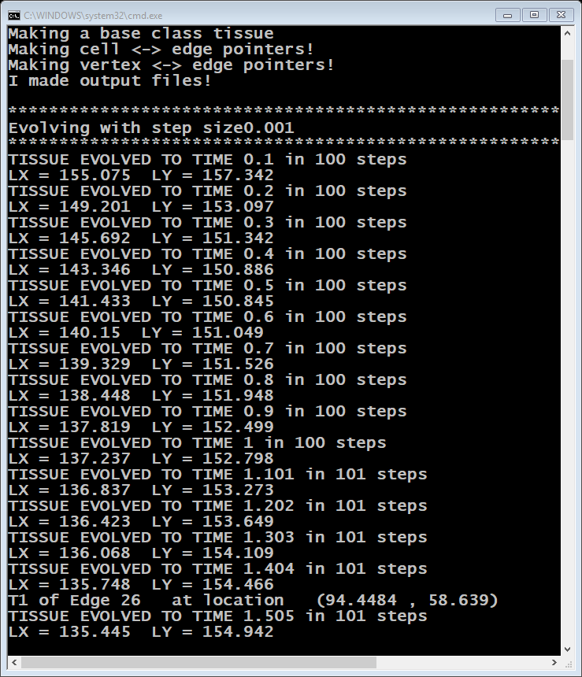

You will now see that in the same folder as mytissue.txt there are also two other files mytissue_error.txt and mytissue_out.txt. They both contain the evolution of your tissue. The error file only records timepoints that are likely to produce errors such as topological changes. When you are writing new code you should call tissue.writeoutputdata anytime you think you will want to see what the tissue is doing at that moment. The out file is used to make movies.

Open matlab and run CreateMovie('mytissue_out.txt'). A window will pop up with a movie of your tissue evolving. All of the individual frames are saved in the new folder which should have been created called mytissue_out.txt_movie

That’s it! You have now successfully run the vertex model. Try changing the parameters in the initialization code and see what happens!

When you are ready to try making bigger changes such as changing the force function see the next tutorial which will walk you through creating sub classes.

